USK VALLEY WORKING GUNDOG CLUB (ID718)

RESULTS OF WORKING TESTS 2012

Working Tests at Park Farm, Caerleon - 25th March
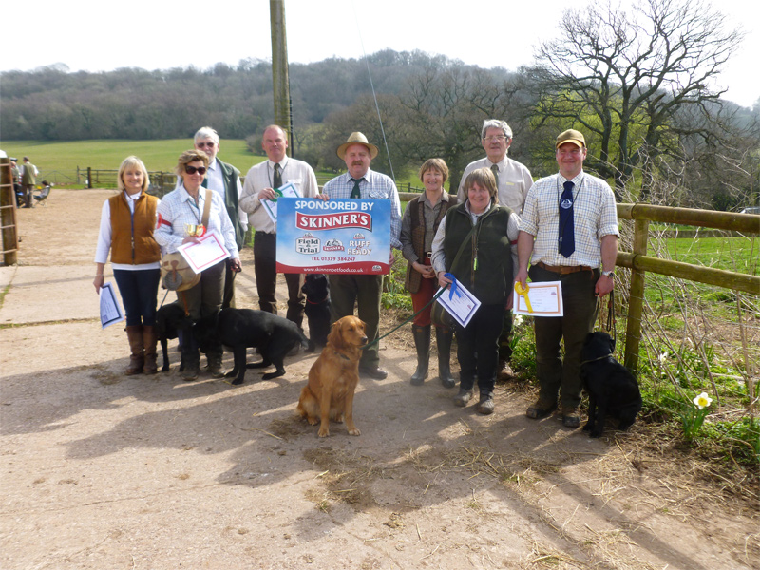 | 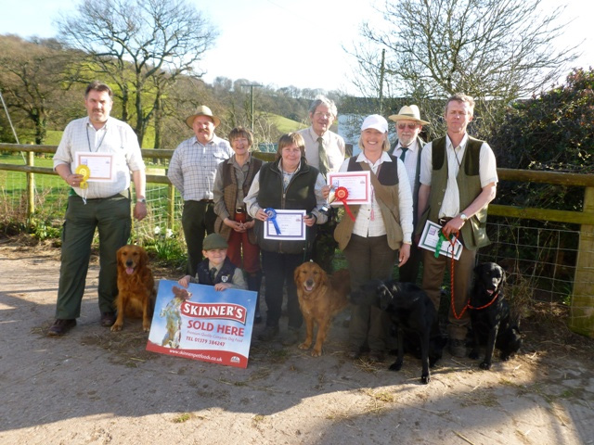
Novice | Open
Once again, we had our first test at Park Farm, by kind permission of Vickie and Martin Prichard. The weather was the first fine, warm day of a long dry spell with summer temperatures. The judges were Dr Gareth Davies, Vickie Prichard, Johnny Morris and Craig Perry.
The morning classes were for Novice dogs, and Novice Dogs/Novice Handlers.
Test 1 consisted of a walk-up in an open grass field for two dogs with two seen retrieves; the first straight and then a crossover.
Test 2 involved two seen retrieves with a mark; the first retrieve was over a fence into a wood, and the second out in an open grass field. Several dogs were reluctant to take the jump.
Test 3 was again in open grass and consisted of two shots; one to a seen and the second to a blind. This test was slightly modified for the ND/NH, where the dogs had two shots to the sides for two seen retrieves; the handler specified which they would take first.
Test 4 proved to be really challenging for both categories. The ND/NH had a straight seen retrieve to a shot alongside a fence and a diagonal seen to a shot by another fence. The second one needed to be retrieved first. There was a nice breeze which should have helped, but most dogs failed on one or the other.
The Novice dogs had a longer retrieve alongside the fence and the diagonal retrieve was a blind, both to a shot. This revealed a big ability gap with the successful handlers using the wind to their benefit.
The afternoon was for Open dogs. If you were among the early running order, you were lucky to ease yourself in with Test 1, again a walk-up with two retrieves to a shot, the same as the Novice test but at a greater distance, so the dogs had the opportunity to show their pace.
Test 2 consisted of a blind to a shot over a fence and ditch into a wood, then a blind to a shot right to the end of an open grass field.
Test 3 was a seen retrieve in the open requiring the dog to go down a dip and then up to the top of the field just in sight. The second retrieve was for a blind across a gulley and up to a dummy concealed in logs by the side of a wooded area. Again, correct use of the wind resulted in success here.
Test 4 was again the most challenging, consisting of a long 200 metre seen to a shot alongside a fence, but the first retrieve was for a diagonal retrieve from a tree pen without a shot.
The results on our scoreboard show that there was a big gap with a number of dogs failing one or more tests. However, there was some excellent work on show.
The Usk Valley Club would like to thank the venue owners, Vickie and Martin, the judges, dummy throwers (particularly Rhianna who was roped in as soon as she arrived, having never thrown dummies before, but also stayed for the Open test - above and beyond the call of duty), and finally Roger Colver for organising the day as Working Test Secretary. We all arrived home at a sensible time!
Penni Gregory
The results were as follows:-
Novice |  |  | Open
1st | Waterford Harrier | Mrs J Coley |  | 1st | Levenghyl Beetle | Mrs C Raymond
2nd | Kaliture Kiche | Mrs L Mixture |  | 2nd | Tiamia Tumble | Mrs L Mixture
3rd | Skeviot Emerald | Mr S Hagain |  | 3rd | Vamp Pippsissewa | Mr A Fisher
4th | Shuttifield Sinbad | Mr M Redpath |  | 4th | Ellijas Danny | Mr L Jackson
COM | Blackthorn Button | Mrs J Beach |  | COM | Merryway Opium | Mr S Pullin
 |  |  |  | COM | Waterford Fergus | Mrs J Coley
Novice Dog/Novice Handler - No awards were made on this occasion

Click here to see the scores for Novice

Click here to see the scores for Open

Working Tests at Miserden, Glos. - 13th May
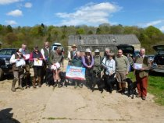 | 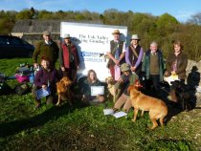
Puppy & Novice | Open
Usk Valley held their second test of the year at Miserden Estate, by kind permission of Major Wills, on a beautiful warm Sunday (amidst some pretty unseasonally wet and cold May weather).
This superb venue enable the possibility of four varied tests, well-distanced from each other, thereby incorporating a gentle cardiovascular workout for some handlers!
The judges for the day were Anne Colley, Terry Dukes, Simon Hagain, John Jones, and Claire Raymond. Competitiors mentioned that the judging carried was carried out in a friendly, helpful manner which made for a relaxing day.
The three categories tested were Puppy and Novice in the morning, and Open in the afternoon. The Puppy tests gave the dogs enough work to be challenging but also enabled them to shine:-
Test 1 was a drive in a fairly steep beech wood with four dogs in a line facing the 'guns'. After the drive was over, the dogs were turned to face the opposite direction and were sent in order up the bank to pick a blind at 30m.
Test 2 was in open meadow along a fence line facing a row of tree with gaps. One dog at a time, it began with a 30m walk to check heelwork, then a mark to a shot; the mark was thrown into an opening in the hedge.
Test 3 was a four dog walk-up with two judges on a hill in open ground. Each dog had a mark in front, then a mark behind. The results were very close, within a point of each other, as can be seen below.
Novice Test 1 was one dog in the line in the gulley, facing up one bank in the wood to a shot distraction, turning the opposite way to retrieve a blind at 50m up the bank. This proved to be very testing for most of the dogs and handlers.
Test 2 consisted of one dog in the line by a fence; firstly there was a diagonal marked retrieve to a shot behind the trees, followed by a blind retrieve along the fence row. The weather became quity windy at this time, making things quite problematic.
Test 3 was the same as the Puppy test, with a 4 dog walk-up, but each dog had a diagonal retrieve to a shot in front, followed by a retrieve to a shot for each dog behind. The results were again within a point of each other.
The Open test was treated to some sunshine and the water test was quite welcome:-
Test 1 was in a wood and consisted of one dog in the line with a mark to a shot, up the gulley to the right at 50m; the first retrieve was a diagonal blind 90m up the bank on the right. There was a good scent for hunting. The dog was then sent for the mark.
Test 2 was similar to the Novice, but out in the open at a greater distance. The first was a seen retrieve to a shot behind the hedge in front at 100m followed by a diagonal blind to the right through the gap in the hedge up the bank by the top fence.
Test 3 was again a difficult mark to a shot across the meadow in front of a ditch across a brook. There was a tempting bridge for the intelligent dogs to find on the way back; not sure how Claire marked this eventuality!
Test 4 was a again a 4 dog walk up with a diagonal retrieve to a shot just over the brow of a hill (90m or so) for each dog; then a marked seen retrieve to a shot behind down the bank for a similar distance. The results are below.
We were delighted to be able to offer a new venue for these tests which appeared to provide a feelgood factor for most competitors in a pretty dire Spring! Again, our sincere gratitude goes to Major Wills for allowing this to happen, and many thanks to John and Lucy Mixture for all their help, and also Martin Weedon, the gamekeeper, for facilitating all this. Not least of all, our appreciation goes to the unsung heroes, the dummy throwers and stewards.
Penni Gregory

The results were as follows:-
Novice |  |  |  |  | Open
1st | Chandkelan Bullitt |  | Mrs S Treadwell |  | 1st | Dealminster Hornet |  |  | Mrs G Herrmann
2nd | Bumblyn Cohosh |  | Mr A Phillips |  | 2nd | Echobrook Fergus Mhor of Asmhorgold |  |  | Mrs K McCarthy
3rd | Mahinda Artichoke |  | Mr E Widdows |  | 3rd | Shuttifield Gracon |  |  | Mrs J Redpath
4th | Oncote Rubyb Valentine |  | Mr G Wright |  | 4th | Ravensthorpe Izzy |  |  | Miss M Treadwell
COM | Damson of Ivyrock |  | Miss E Davis
COM | Wotton Spice |  | Miss S Eatwell
Puppy
1st |  | Slipside Ebony |  | Mr P Green
2nd |  | Ffynongain Utter Magic |  | Dr G Davies
3rd |  | Norton Chincilla of Chemsell |  | Mrs J Ellin
4th |  | Wainhawke Beatrice |  | Mrs C Gray
COM |  | Chiclittle Boy of Oncote |  | Mr B Clay
COM |  | Gillhays Thyme |  | Miss A Portlock
Click here to see the scores for Novice
Click here to see the scores for Puppy
Click here to see the scores for Open

Working Tests at Clytha Park - 10th June
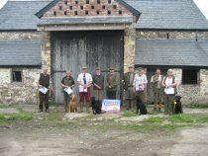 | 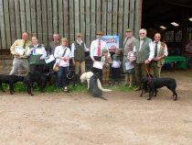
Award winners from the morning | Award winners from the afternoon
Quite unexpectedly, the weather was dry and overcast in the morning; just right for working retrievers. We were here again by kind permission of Sir Richard Hanbury-Tennison. The tests were for Novice Dog/Novice Handler, Novice, Puppy, Veteran, and Junior Handler. Our judges were Tyrone Axford (Sarge), Lisa Harris, Richard Price and Roger Wiggins.
Test 1 for Novice, judged by Roger Wiggins, was a two dog walk-up in open ground, in short grass with thistles - a cross over double mark, then swapped over for the other. This tested steadiness, heelwork and the dogs' ability to mark.
The Puppies had to demonstrate good heelwork for 30m, then steadiness, and send for a marked retrieve in front at 60m.
The Junior Handlers had their heelwork checked, then steadiness with a 60 yd. marked retrieve, followed by a blind in the same place.
The Veterans had the same, but at a greater distance.
Test 2 for Novice, judged by Richard Price, was a marked retrieve to a shot in woodland in front, followed by a blind retrieve to the right through some cover; the cover was tall enough for the handler to lose sight of the dog, enabling it to demonstrate its natural hunting ability.
The Puppies had a 50m marked retrieve to a shot, thrown from cover, on a grassy ride in front.
The Junior Handlers had a marked retrieve.
Test 3 for Novice, judged by 'Sarge', was a marked retrieve across a lake, well back into long grass; the scent was not brilliant in the area and quite a few dogs struggled to find the mark. Once this had been picked, there was a blind retrieve at right angles in front of the lake at the base of a bush.
The Puppies had a marked retrieve; a dummy thrown from the other side of the lake with a 30m swim.
The Junior Handlers had the same seen water retrieve at the far side of the lake.
Test 4 for Novice, judged by Lisa Harris, was in woodland down a track to test heelwork, then a marked retrieve 80 yd. down the track followed by a blind retrieve in the same place. Good heelwork and marking ability scored the points here.
The Puppies had to walk to heel for 60m where a dummy was thrown from cover onto the ride for a 50m retrieve; they then had a blind retrieve in the same spot with no shot.
The Junior Handlers had a 100 yd. marked retrieve into the corner of a field followed by a blind retrieve in the same place.
A smaller entry than usual made for a very relaxed and enjoyable day. Our thanks go to Alan the gamekeeper for being so helpful, the invaluable dummy throwers, caterer Pat Williams, our judges, and Sir Richard for allowing the event to take place on his estate.
Penni Gregory
The results were as follows:-
Novice |  |  |  | Puppy
1st | Skeviot Emerald | Mr S Hagain |  | 1st | Ffynongain Utter Magic | Dr G Davies
2nd | Tanjin Sharapova | Mrs S Parkes |  | 2nd | Gillhays Sage | Mrs D Polley
3rd | Slipside Diplomat | Mrs D Bird |  | 3rd | Ffynongain Used | Dr G Davies
4th | Rasheeka Secret Tune | Mr G Rogers |  | 4th | Slipside Ebony | Mr P Green
 |  |  |  | COM | Hassycott Whislefish Fin | Mr M Redpath
Novice Dog Novice Handler |  |  |  | Veteran
1st | Kendeci Cherry Blossom | Miss C Brailsford |  | 1st | May Ebony | Mrs J Redpath
Junior Handler
1st | Meadow Island Wild Fern of Glasybont | Llywelyn Price
2nd | Callowhill May of Glasybont | Owain Price

Click here to see the scores for Novice
Click here to see the scores for Puppy

Click here to see the scores for NDNH

Click here to see the scores for Veteran

Click here to see the scores for Junior Handler

Working Tests at Trippen Kennett - 2nd September
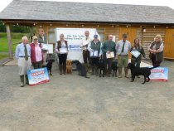 | 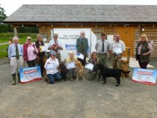 | 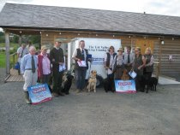
Puppy | Novice | Open
Our final working tests for this year were again at Trippen Kennett farm at Three Ashes near Ross on Wye. We received our usual warm welcome form the landowners, Richard & Gwyneth Williams who are so accommodating, which has enabled us to put on some really interesting tests this time.
The weather was again kind to us; starting out overcast, nice and cool for the dogs, warming up later in the morning, but with three tests involving water they remained happy!
Test 1 was judged by Gill Wright on the big lake. The Puppies and Novice dogs had a good distance to swim for a marked dummy to a shot in the water; the Novice dogs having to swim a good 50m almost to the far bank, and return across the lake.
Test 2 was judged by Julian (Jub) Price using a very useful pond that had appeared thanks to former traditional UK August holiday weather (rain, followed by more of the same!). The Puppies and Novice dogs had a marked retrieve in the water and another in the opposite direction in the field; they needed to demonstrate steadines by walking to the edge of the pond to watch the dummy thrown into the water, then walk away from the pond to heel and wait to be sent back for the retrieve.
Test 3 was judged by Lucy Jenkins who likes her obedience (Goldie's are good at it!), and carefully scrutinised the handler's ability to get their dog to walk beautifully to heel from one post to another. She then walked the puppies to the side of a brook where they had a marked retrieve to a shot on the opposite side a little way up the bank in an open field. This really tested a yound dog's confidence and ability to jump down into the water, retrieve over the other side and get back up a wet, muddy bank. The Novice dogs had a similar exercise but were sent across further back from the bank, and the marked retrieve was higher up the field.
Test 4 judged by Terry Dukes, was in an open field with two marked retrieves to a shot at a right angle for the Puppies; the first out in the field followed by the second down near the hedgerow. The Novice dogs had similar but at a greater distance and the second retrieve was a blind to a shot. This also tested the dog's ability to ignore other things in the grass besides the dummy - a few of us have now earned sheep-herding badges for skills demonstrated before the tests could begin (am and pm!).
The Open tests in the afternoon were obviously more demanding but very interesting for handlers. Test 1 in the lake required the dogs the dogs to swim across the water, negotiate the reeds, go up a long bank and find a blind to a shot over the top of the bank down in a gulley out of sight. If the dog returned round the side of the lake they were deducted 5 points -a good training assessment!
Test 2 involved a starting point at the top of the field where the dogs could see and hear a dummy thrown into the reeds in the pond to a shot well down the field, followed by a blind to a shot in the top corner at right angles; the seen in the water to be retrieved first.
Test 3 again started with heelwork from A to B with a halt on command near the end. Lucy assured us that her walking behind the dog was good experience for trialling! The dogs then had to retrieve a blind across the brook and up the bank to a shot.
Test 4 was a shot fired in the corner of the field with a dummy for the dog to retrieve out of sight, followed by a shot for a blind in front of the hedge at 90 degrees - the first one to be retrieved first. A good chance for dogs to show their speed in the dry!
The awards ceremony took place in the dry (touch and go!). We are thoroughly indebted not only to Richard & Gwyneth and our judges, but also all the dummy throwers and stewards who gave up their time to suport the handlers and their dogs, the ladies who carried out secretarial duties and selling raffle tickets, and last but not least Joy Elson for providing the excellent lunch. We would also like to thank Roger Wooldridge for all the wonderful photos he took on the day - some of which will be appearing on this website shortly!
Penni Gregory
The results were as follows:-
Novice |  |  |  | Open
1st | Bitennam Golden Larch of Greyhill | Mr J Jones |  | 1st | Skeviot Topaz | Mr S Hagain
2nd | Ffynongain Uttter Magic | Dr G Davies |  | 2nd | Geldert Alice | Mr R Kirk
3rd | Nordenlights Yucatan | Mrs S Parkes |  | 3rd | Pippins Promise | Mrs K Green
4th | Cynhainfa Jarmen of Wauniago | Mr M Jones |  | 4th | Kilpen Pinoccio | Mrs K Pennell
COM | Courtridge Cody | Miss J Lauria |  | COM | Vamp Parsley Potage | Mrs V Prichard
COM | Damson of Ivy Rock | Miss G Davies
Puppy
1st | Hassycott Whistlefish Fin | Mr M Redpath
2nd | Croftferry May | Mr S Prosser
3rd | Gillhays Sage | Mrs D Polley
4th | Harry Allen | Miss R Parsons
COM | The Windbreak Whisperer | Miss C Baker
COM | Mucklhart Gracie | Mrs D Cornforth

Click here to see the scores for Novice
Click here to see the scores for Puppy
Click here to see the scores for Open
Finally, we held our Skinner's Challenge again this year (the dog with the most points across all 4 tests), and are delighted to announce that the winner for 2012 is Simon Hagain with Skeviot Emerald who will receive a Skinner's bag of dog food and an embroidered fleece. Congratulations and well done to Simon!

